Flora Exercise

AN 3571 Professor Suzanne Spencer-Wood Archaeological Methods and Theory

Marcus Dennehy

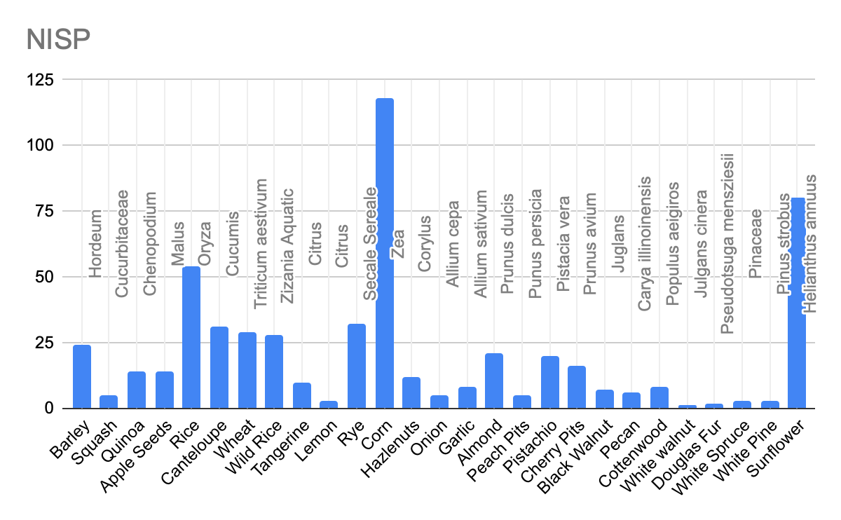

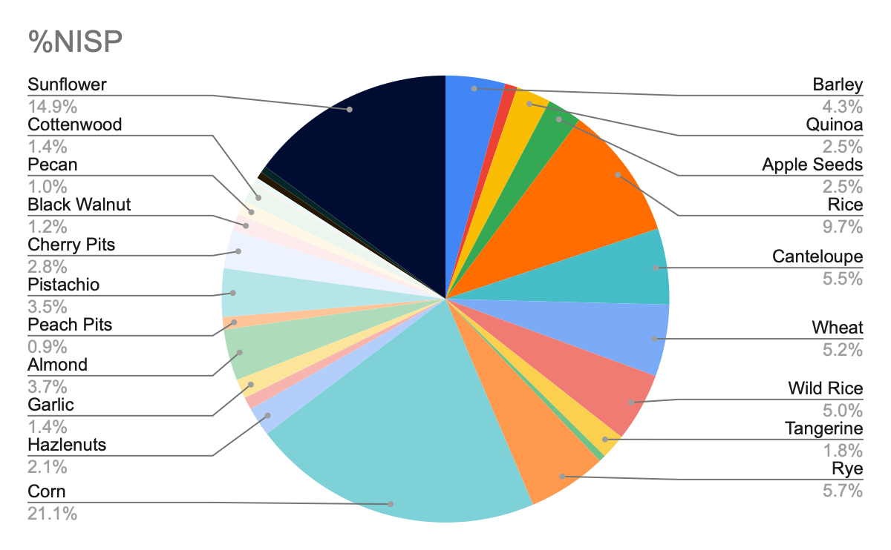

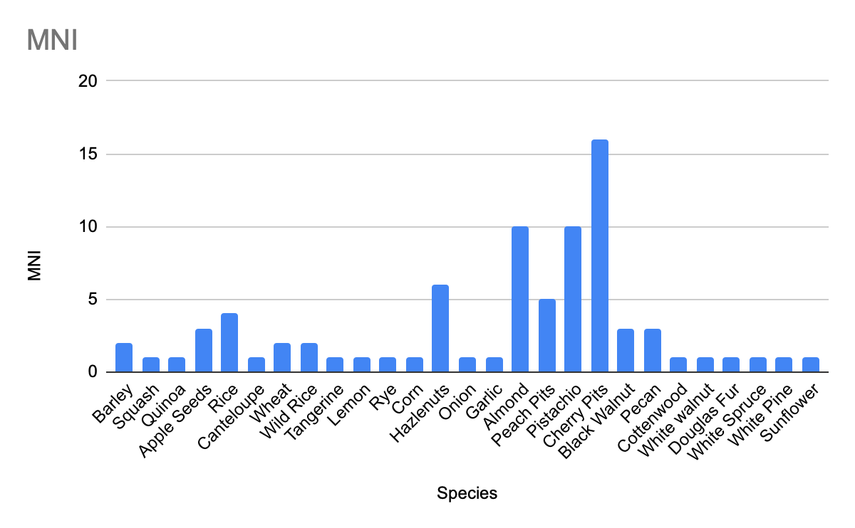

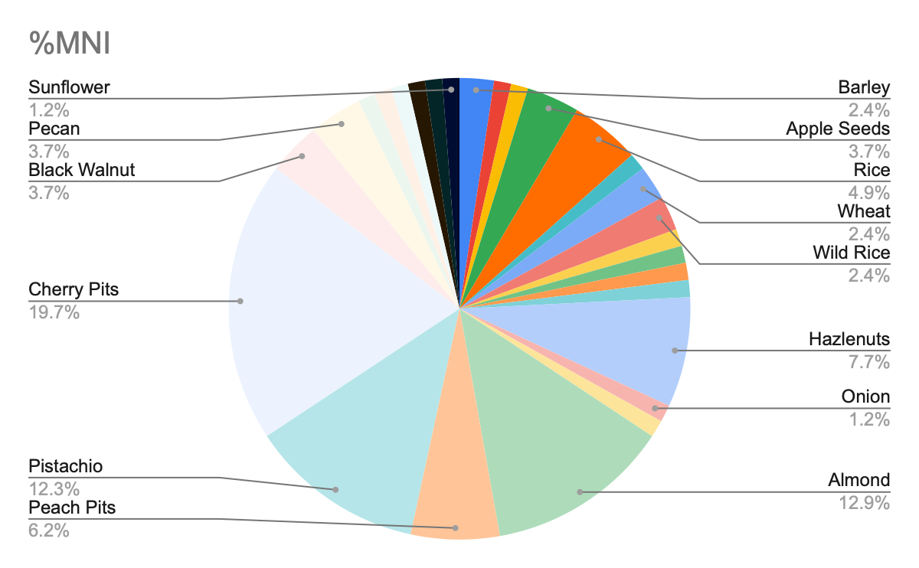

5.) The NISP is different from the MNI in a variety of ways. The NISP can count fragments of shells and kernels of a corn, but it does not count for one whole individual. Domesticated corn kernels are made out of hundreds of seed kernels. The MNI shows us the minimum amount out of those fragment pieces and gives us entirely different information. By comparing the two we found some interesting contrasts. NISP shows corn and sunflower kernels were counted with the majority of those findings. While MNI shows that Cherry, Almond, and Pistachio were all in the majority. NISP shows the variety of diet a human can be eating, a vast range of food eaten can be seen at this sight. The MNI shows that the majority of plants found within this category indicates a lot of consumption from humans.

6.)

A.) The wild plant species suggest that this was a very temperate environment. Cherry pits possibly indicate the midland Great lake area, as other plants like wild rice and corn as it is native to the Americas.

B.) The most likely plants like wild rice, squash, sunflower seeds and quinoa. These were all identified at this site, and were most likely eaten often. The prehistoric Americans left over a lot of sunflower seed shells, so they were consumed often.

C,)Historic Europeans might have been cultivating old world grain like rice, wheat barley, cantaloupe, apple, onion and garlic.

D.) These were all found on the site and suggest a lot of European settlement. Many of these like sunflower seeds originated from the American Indians, like corn and squash. But a vast quantity of different types of cultivated old world plants can be found here as well. This suggests a european takeover to turn into agricultural land for grain and other vegetables.

7.) Sunflower seeds were most popular with the prehistoric Americans, as a vast amount of sunflower seed shells are found here. Corn kernels, which are another cultivated prehistoric American plant, are found here in abundance as well. Cherry pits, however, as well as other nut shells like pistachio and almond provide a vast arrange of fruits and nuts, providing a fiber rich diet. The nuts, also supplying the much needed protein for the winter months and can be stocked.

8.) There is strong evidence suggesting that this was a permanent settlement year round. Nuts usually can be harvested in the fall and as said previously, can be stocked for the winter months. Spring brings about new growth of cherries, corn and other grain. The summer harvest brings about cantaloupe and squash. The diversity and the arrange of seasons that the floral patterns suggest tells us that this was a permanent abode.

9.) Black walnuts and other shelled plants can identify mold and pseudomonas commensals on the outer rims of the shell. However I did not find any of this while identifying the floral patterns.

10.) The difficulty with trying to understand the diet of these peoples is how the NISP and MNI have different stories of what these people ate. The seeds cannot be properly counted while broken and therefore skew the data of the NISP. The only way this could be evened out is if we found more variety of seeds in our floral pattern study. However, we are at the extent of our research and cannot count further. Root crops like radishes, beetroot and potatoes cannot be identified correctly as they reproduce through asexual means, so microfloral analysis is off the table. Which is one of the reasons why samples are problematic, they are only a small scope of what these people ate. The more data we find, the more that is unearthed, sample by sample can only give us spoonfuls of knowledge. However, a look into the past is not an opportunity to be let go. So these samples of floral taken from this site here can show us so much about the past, but so little as the same time.